**Probability and Statistics - IT2120**

**Lab sheet 6**

**IT NO: IT24102364**

**Name: Sanjana K.D.A**

**Question 1**

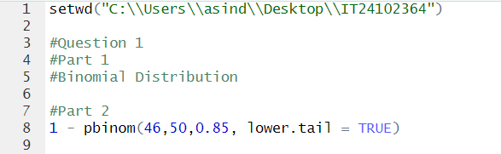

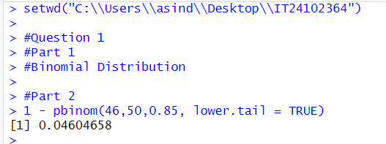

**Question 2**

